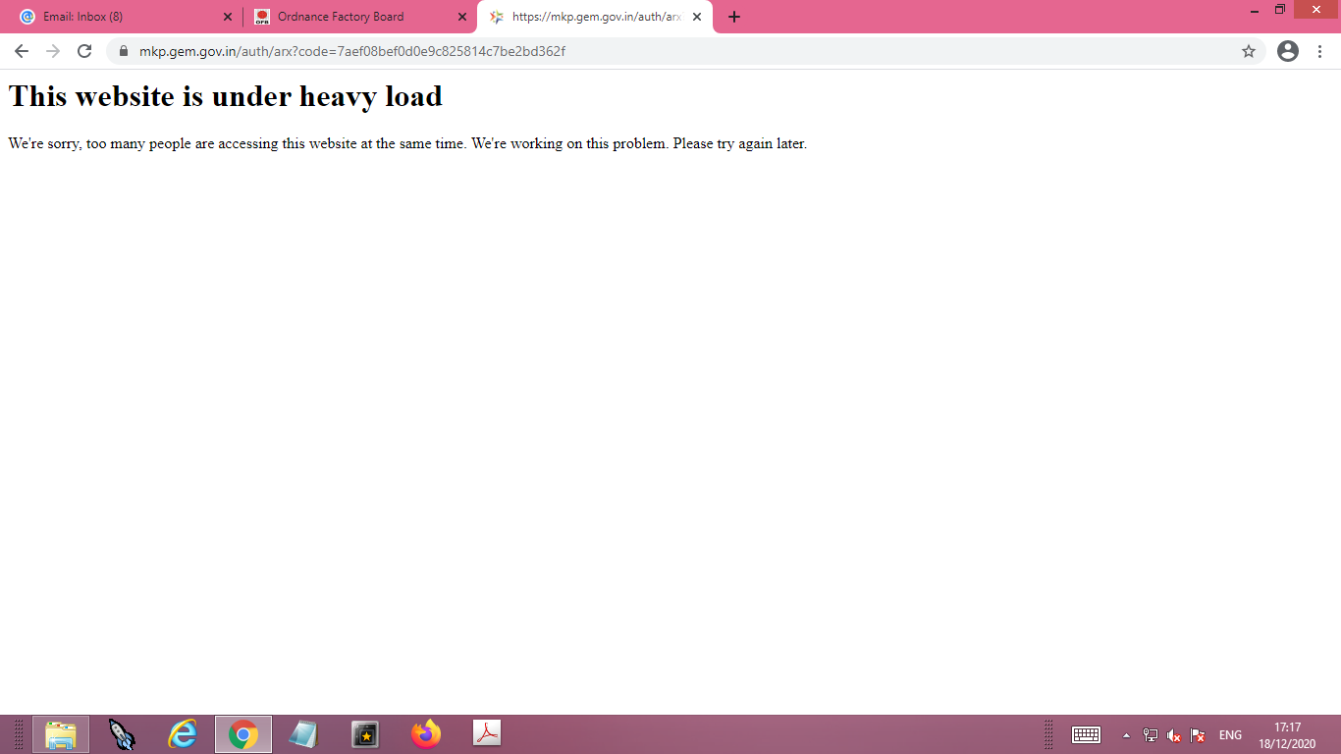

Documentary proof of past experience with completion certificate (executed similar services in last three years) and an office located in the state of consignee to be submitted within 2 days.

