Hexagon Bolts with reduced head,
Product Grade A
Construction and Dimensions

GOST 7808 - 70

Translated by:
M/s SWYAZ
2/453, Viram Khand, Gomti Nagar

Lucknow – 226010
: 0522–3098139 / 2345145 Visit us:
http\\:www.swyaz.com

Inter State Standards

Hexagon bolts with reduced head,
product grade A

GOST
Construction and Dimensions 7808 - 70

ОКП 12 8200

Date of introduction 01.01.72

1. This standard pertains to bolts with hexahedral reduced class head of precision A with thread diameter of from 8 to 48 mm.
(Amended edition, Amendment No.4).
2. Design and sizes of bolts should correspond to those indicated on the drawing and in table 1, 2.
(Amended edition, Amendment No.2 - 6).
3. Threads - as per GOST 24705. Run-outs and under-cuts of threads - as per GOST 27148. Ends of bolts - as per GOST 12414.
(Amended edition, Amendment No.5).
3a. Radius for head – as per GOST 1759.1.
3b. Tolerance of dimensions, deviation of forms and location of surfaces not established according to this standard, as per GOST 1759.1.
3c. Permissible defects at surfaces of bolts and methods of inspection – as per GOST 1759.1.
3a – 3b. (Introduced additionally, Amendment No.5).
4. By agreement between manufacturer and customer it is permitted to manufacture:
- bolts of make 1 and 2 with head thickness, equal to k1;
- bolts with nominal thread diameter of from 36 to 48 mm with 2 mm pitch of thread.
(Amended edition, Amendment No.2, 4).
5. Version of make of head is set by manufacturer.
5a. According to agreement between manufacturer and user, manufacturing bolts with diameter of smooth part of rod d₁, approximately equal to mean thread diameter, is permitted.
5b. Carrying signs of marking, it is permitted to manufacturer bolts of make 1 and 2 with hole on face with sizes, with not decreasing strength of head, during this depth of hole should not be more than 0.4 k.
5a, 5b. (Introduced additionally, Amendment No.5).
6. Technical requirements – as per GOST 1759.0.
7. (Deleted, Amendment No.2).
8. Mass of bolts specified in appendix 1.
9. (Deleted, Amendment No.4).

GOST 7808-70 Page 2

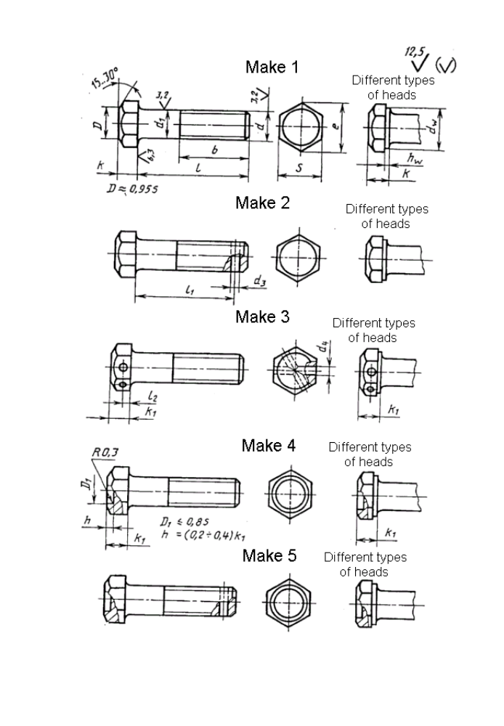

GOST 7808-70 Page 3

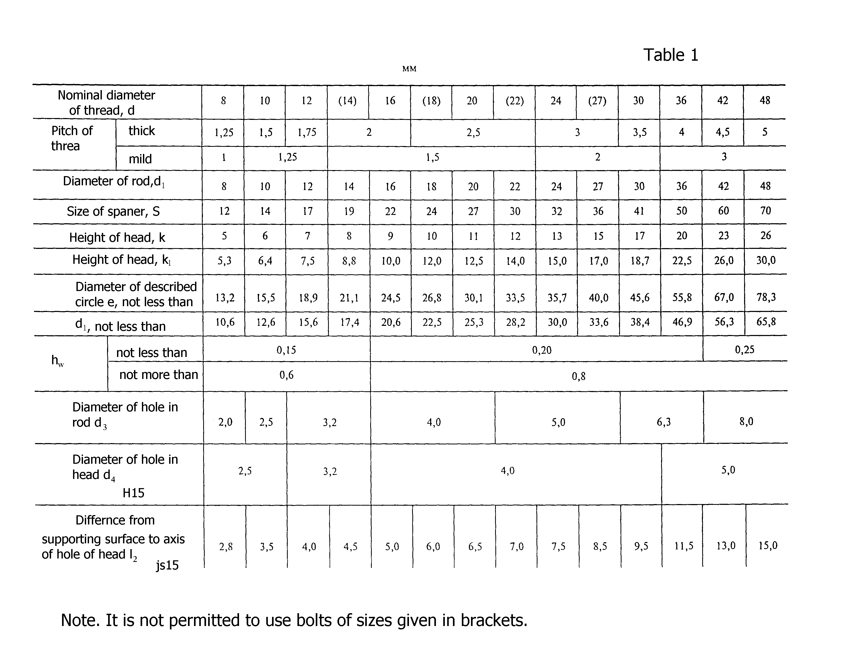

GOST 7808-70 Page 4

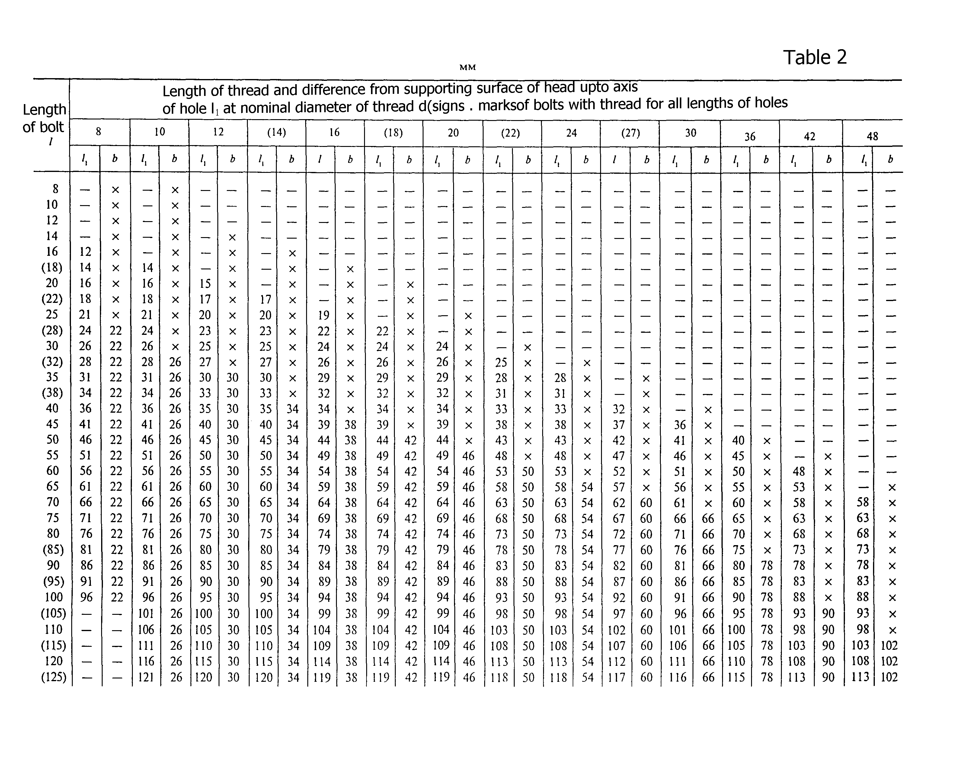

GOST 7808-70 Page 5

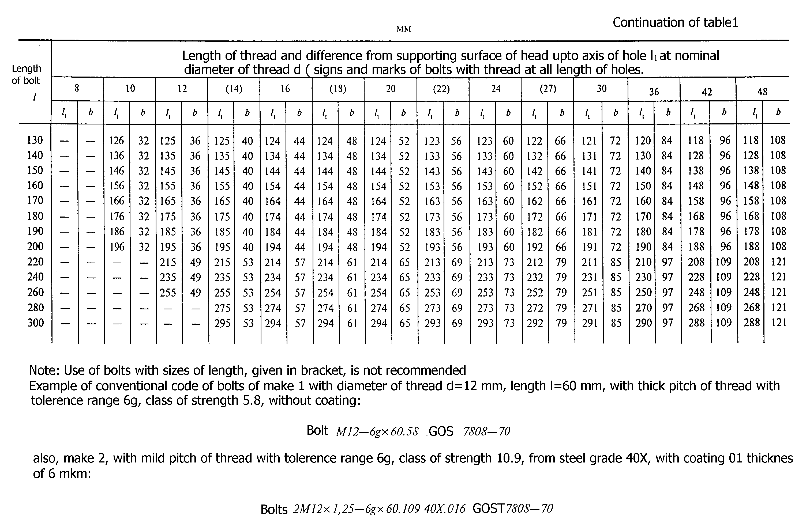

GOST 7808-70 Page 6

Mass of steel bolt (make 1) with thick pitch of thread

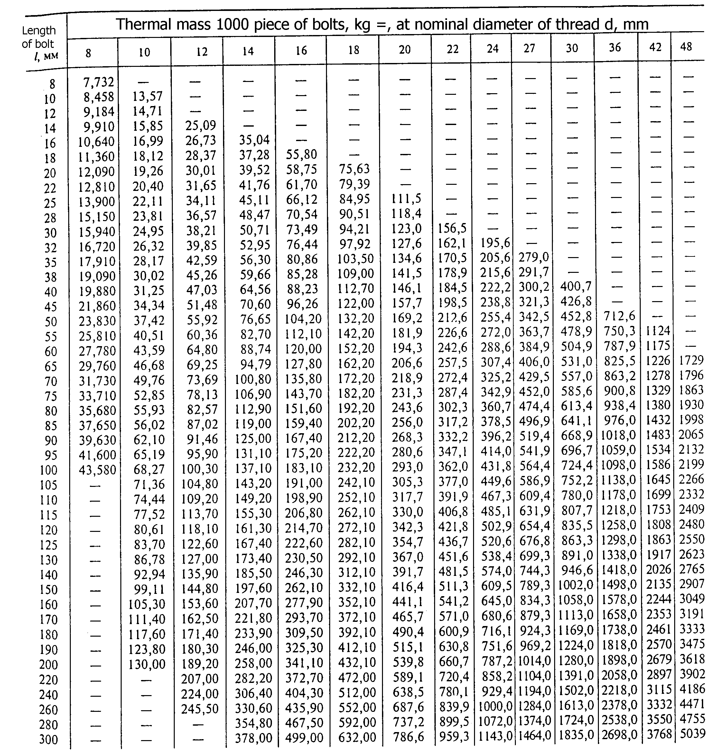

For determination of mass from other materials of mass value, specified in table, should be
Multiplied with coefficient : 0.356 – for aluminum alloy; 1.080 – for brasses.
Appendix 1. (Amended edition, Amendment No. 5, 6).
Appendix 2. (Deleted, Amendment No.6).

GOST 7808-70 Page 7

Supersedes GOST 7808-62

Reference normative-technical documents

Description of HTД, where reference are given | Number of Point | Description of HTД, where reference are given | Number of Point
GOST 1759.0-87  GOST 1759.1-82  GOST 1759.2-82  GOST 12414-94 | 6  3б  3в  3 | GOST 24670-81  GOST 24705-81  GOST 27148-86 | 3а  3  3

Reprinted with Amendment No. 2, 3, 4, 5, 6, approved in February 1974, March 1981, May 1985, March 1989, June 1995 (ИУС 3 – 74, 6 – 81, 8 – 85, 6 – 89, 9 - 95)

